Equal Opportunities
This information helps us to work with lots of different people.
This will not be used for your application. The tutors will not see it. Your answers will be private.
You can tick, underline or write your answers.

About you
  Sex at birth | Male  Female  Intersex  Prefer not to say
Gender | Male  Female  Non-binary  Other:__  Prefer not to say  If your sex at birth is different to your gender please tick or underline this answer


Date of birth


Post code

  Ethnicity | Asian / Asian British  - Indian  - Pakistani  - Bangladeshi  - Chinese  - Any other Asian background  Black / African / Caribbean / Black British  - African  - Caribbean  - Any other Black / African / Caribbean background  Mixed / Multiple ethnic groups  - White and Black Caribbean  - White and Black African  - White and Asian  - Any other Mixed background  White  - English / Welsh / Scottish / Northern Irish / British  - Irish  - Gypsy or Irish Traveller  - Any other White background  Other ethnic groups  - Arab  - Latin American  - Any other ethnic group
  Sexuality | Bisexual  Gay Man  Lesbian/Gay Woman  Heterosexual/Straight  Queer  Prefer not to say  Other__________________________________________
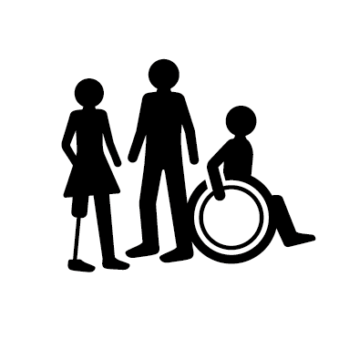  Disability | Disabled  Non-disabled  Deaf  Neurodivergent  Other words you would use to describe yourself____________________

How you find out about opportunities
  How did you hear about this course? | Facebook  Instagram  Twitter  Access All Areas’ website  TV  Through a community group  Through your school or college  Through a friend or family  Other: ____________
  If you are researching training, what do you usually look at? | Search Engine such as Google or Bing  Talking to people you know  Learning disability and autism blogs, magazines and websites  Other: ________________

You and media
How often do you use the following: | Never | Rarely | Sometimes | Often | Very Often | Doesn’t Apply
TV
Radio
Magazines
Blogs and Online Magazines
Newspapers
Facebook
Instagram
Snapchat
TikTok
Search Engines such as Google or Bing
If you read any newspapers, magazines, webzines or blogs, tell us which?

How likely are you to pay attention to news updates using the following ? | Unlikely | Quite unlikely | Neither likely nor unlikely | Quite likely | Very Likely | Doesn’t Apply
Instagram or Facebook Stories
Social media posts with words
Social media posts with pictures
Social media or You Tube videos
Newsletters

Articles

Thank you for completing this form.

Your answers will help us to work with lots of different people in the future.

