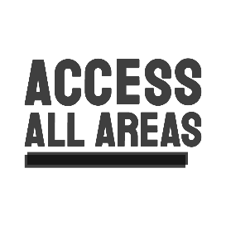 | 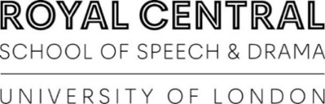 | 

Performance Making Diploma 2025 - 2027

 | This is the application form for the Performance Making Diploma.
 | The course starts in October 2025.
 | Please try to fill in all the boxes.  You can ask someone to support you or write your answers in.
   | For the Personal Statement section you can choose to write or send us a video.
 | If you need information or support filling in the form you can contact  sophie@accessallareasproductions.org  0207 613 6445

Your details

This section is so we know who you are and how to contact you.

  Photo | You can add a photo here or attach one to your email.


Name


Phone number


Email



Address



Emergency contact name and number

Your support

Tell us about who is supporting you with this form.

If nobody is supporting you with the form, leave this section blank.



Supporter name and who they are to you



Phone number



Email



Would you like us to include this person when we contact you?



Will you have a support worker with you in the audition workshops?

Your personal statement

In this section we want to know about you as an artist.

You can:
- Fill out these boxes
- Write a separate page
- Send us a video (up to 5 minutes)
- Send us a voice recording (up to 5 minutes)

If you are sending a video or voice recording, please send to us through WeTransfer.

There are instructions at the end of this document.



Why do you want to study on the Performance Making Diploma?


What do you want us to know about you?





Tell us about your creative experience

This could be

- Drama clubs
- Performances
- School plays
- Dance
- Film



Tell us about a performance you have seen.

This could be

- Theatre
- TV
- Film
- Something else!

You could tell us about

- The acting
- The design
- The story
- What you liked
- What you didn’t like

You can write up to a page (or record up to 2 minutes)

Your education and employment

In this section we want to know a bit more about what you have learnt and done already.

You do not have to have any qualifications or professional experience. These questions are to help us get to know you.



Please tell us about

- What school, college or university you went to
- What you studied
- What qualifications you got
- What year you finished

You do not have to tell us everything- give us the highlights!



Please tell us about

- Paid or unpaid work
- When you did it

You do not have to tell us everything- give us the highlights!

Your access requirements

This section is about your access needs. This is so we can make the auditions accessible for everybody.

Information you give in this section will not affect our decision about offering you a place.




Do you use a wheelchair, cane or other mobility aid?

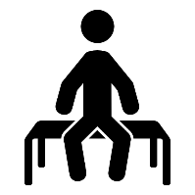

Do you need to take extra breaks?

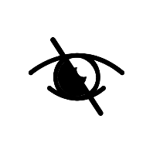

Do you have a visual impairment?



Are you Deaf or hard of hearing?

Please tell us if you need a hearing loop, BSL interpreter or anything else.



Do you use Makaton?



Do you need a quiet room?



Tell us about any sensory needs you have. This might include:
- Bright lights
- Loud noises
- Touch
- Anything else!



Tell us about any needs you have around anxiety and stress.

You could tell us
- What makes you anxious
- How you might act when you are anxious or stressed
- What helps you in these situations



Tell us about any health needs that might affect you in auditions.

This could include
- If you have epilepsy
- If you have chronic pain
- If you take medication which might affect you in auditions
- Allergies which might affect you in auditions

Film and photo permission

We might take photos or film of the auditions.

These might be used on the website or social media accounts of Access All Areas, Netflix and The Royal Central School of Speech And Drama.

If you do not want your picture or video to be used online, please tell us.

Do you give permission for photos and videos of you to be used?

Declaration

If you agree that all the information in this form is correct, please sign below.



Signature

Name

Date

How to send us your files

 | WeTransfer is a website that allows you to send larger files – like videos or voice recordings.  You can send us video or voice recordings using WeTransfer, if you would like
 | Once you have created your video or sound files, please click the link:  https://wetransfer.com/
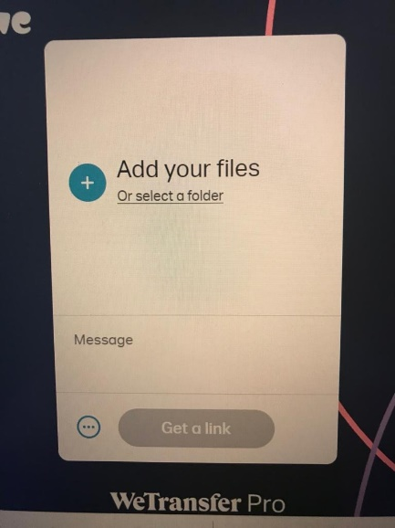 | You should see a white box on the left of the screen.  Click the blue plus ‘+’ button
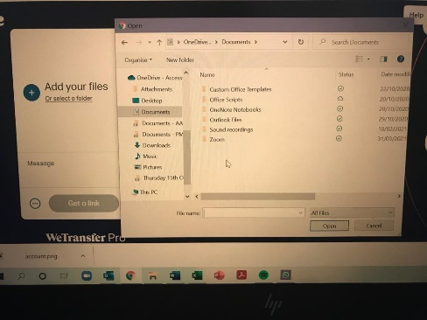 | Look through your computer files and select the video or voice recording you want to send
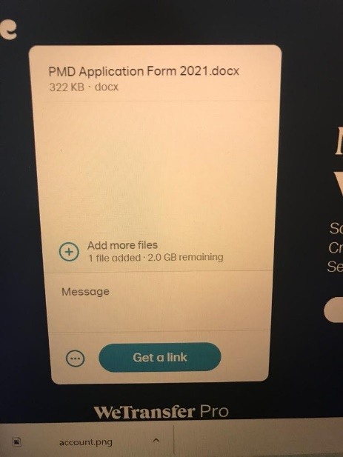 | The name of your file will appear at the top when it has loaded.  You can type a message in the box where it says ‘Message’
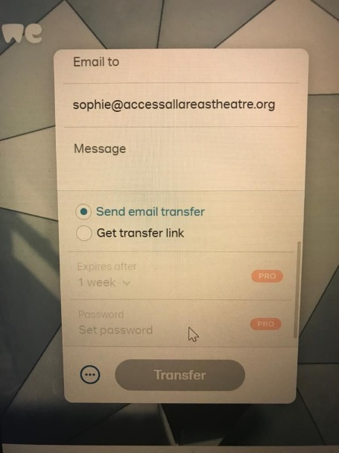 | Make sure there is a dot next to ‘Send email transfer’  In the ‘email to’ box, put sophie@accessallareasproductions.org  Click the big ‘Transfer’ button at the bottom
 | If you have any questions, please contact Sophie
 | 07805 490 878  sophie@accessallareasproductions.org

